Software Design Document (SDD)
Module:I2C Driver
Version: 1.0
Author: De La Torre Gomez Aldo Sebastian 37969, Cuadros Troncoso Pedro 37795, Garcia Veliz Oskar Liborio 38265

1. Introduction

1.1. Purpose
This document describes the software design and architecture of the I2C driver module developed for the STM32F411RE microcontroller, as part of the Microcontrollers and Embedded Systems course at CETYS Universidad. The design is based on the requirements defined in SRS-I2C_Driver v1.0 and provides details on data structures, enumerations, register-level algorithms, and control flow to guide implementation and testing. This SDD also serves as a reference for maintenance, testing, and future improvements of the I2C driver firmware.

1.2. Scope
The I2C driver is a low-level software component for embedded systems. It abstracts STM32 hardware I2C registers (CR1, CR2, CCR, TRISE, SR1, SR2, DR) and provides a clean C API for higher-level modules such as sensor drivers and peripheral interfaces. The system performs the following specific operations:
- Configures I2C1 in Standard Mode at 100 kHz using PB8 (SCL) and PB9 (SDA) with Alternate Function 4 (AF4) open-drain configuration.
- Provides register-based write (i2c_writeRegDevice) and direct write (i2c_writeDevice) operations for transmitting data to I2C devices.
- Provides register-based read (i2c_readRegDevice) and direct read (i2c_readDevice) operations, handling single-byte and multi-byte reception per RM0383 Fig. 164.
- Validates all device addresses against the 7-bit I2C specification (0x08-0x77) and validates buffer pointers and length arguments, returning I2C_Status_t error codes (NFR-2).
- Implements automatic bus recovery (i2c_recover) by clocking SCL up to 9 times to release a slave stuck mid-byte, followed by a manual STOP and peripheral software reset.
- Does not depend on HAL or LL libraries — all hardware interaction uses direct MCU register access through CMSIS I2C_TypeDef and RCC_TypeDef.

1.3. Definitions, Acronyms, and Abbreviations

Term | Definition
I2C | Inter-Integrated Circuit — two-wire synchronous serial protocol (SCL + SDA).
SCL | Serial Clock Line — driven by the master to synchronize data transfer.
SDA | Serial Data Line — bidirectional open-drain data line.
CR1 | Control Register 1 — PE, START, STOP, ACK, SWRST bits.
CR2 | Control Register 2 — FREQ field (APB1 clock in MHz).
CCR | Clock Control Register — CCR = fAPB1/(2×fSCL) in Standard Mode.
TRISE | Maximum Rise Time Register — TRISE = fAPB1_MHz + 1 in Standard Mode.
SR1 | Status Register 1 — SB, ADDR, TXE, RXNE, BTF, AF, BERR, ARLO flags.
SR2 | Status Register 2 — BUSY, MSL; reading SR2 after SR1 clears ADDR.
DR | Data Register — write: shifts out on SDA; read: byte received from SDA.
SB | Start Bit flag — set after START condition is generated.
ADDR | Address Sent flag — set after 7-bit address + R/W is acknowledged.
TXE | Transmit Data Register Empty — set when DR accepts new byte.
RXNE | Receive Data Register Not Empty — set when DR holds received byte.
BTF | Byte Transfer Finished — full byte transferred, DR ready.
ACK/NACK | Acknowledge / Not-Acknowledge — 9th bit of each I2C byte.
BERR | Bus Error — misplaced START or STOP condition.
ARLO | Arbitration Lost — master loses bus arbitration.
AF | Acknowledge Failure — no ACK received from slave.
SWRST | Software Reset bit in CR1 — clears all I2C state.
FR-x | Functional Requirement x — defined in SRS-I2C_Driver v1.0.
NFR-x | Non-Functional Requirement x — defined in SRS-I2C_Driver v1.0.
HAL | Hardware Abstraction Layer — NOT used; driver uses direct register access.
CMSIS | Cortex Microcontroller Software Interface Standard.

1.4. Requirements
All requirements for this module are allocated in SRS-I2C_Driver v1.0. This document covers FR-1 through FR-10 (functional) and NFR-1 through NFR-3 (non-functional).

Req. ID | Type | Description
FR-1 | Functional | i2c_init() shall configure the I2C peripheral to a default state (CR2, CCR, TRISE for 100 kHz at 16 MHz APB1, software reset, PE enable).
FR-2 | Functional | i2c_init() shall enable clocking for GPIOB (AHB1ENR) and I2C1 (APB1ENR) before any register access.
FR-3 | Functional | i2c_writeRegDevice() shall send device address and register address, then transmit data: START -> ADDR(W) -> REG -> DATA[0..n] -> STOP.
FR-4 | Functional | i2c_writeRegDevice() shall transmit multiple bytes using TXE polling loop followed by BTF before STOP.
FR-5 | Functional | i2c_writeDevice() shall send device address and transmit data without register phase: START -> ADDR(W) -> DATA[0..n] -> STOP.
FR-6 | Functional | i2c_writeDevice() shall transmit multiple bytes using TXE polling loop followed by BTF before STOP.
FR-7 | Functional | i2c_readRegDevice() shall send register pointer then Repeated START: START -> ADDR(W) -> REG -> Rep.START -> ADDR(R) -> DATA[0..n] -> STOP.
FR-8 | Functional | i2c_readRegDevice() shall read multiple bytes handling single-byte and multi-byte sequences per RM0383 Fig. 164, including ACK/NACK management.
FR-9 | Functional | i2c_readDevice() shall send device address in read mode and receive data without register phase: START -> ADDR(R) -> DATA[0..n] -> STOP.
FR-10 | Functional | i2c_readDevice() shall read multiple bytes with same ACK/NACK management as i2c_readRegDevice() per RM0383 Fig. 164.
NFR-1 | Non-Functional | The driver shall be lightweight and efficient: direct register access, no HAL/LL dependency.
NFR-2 | Non-Functional | The driver shall validate address (0x08-0x77), NULL buffer, and len>0 before any hardware access, returning I2C_Status_t on failure.
NFR-3 | Non-Functional | All flag-polling loops shall include I2C_TIMEOUT (160000 cycles, ~10 ms); no operation blocks indefinitely.

2. System Architecture

2.1. High-Level Design
- Layered Architecture:
- Application Layer: main.c calls adxl345_driver API. Never accesses I2C registers directly.
- Sensor Driver Layer: adxl345_driver.c uses I2C driver public API exclusively.
- I2C Driver Layer: i2c_driver.c — the only layer accessing I2C1 registers and RCC.
- Hardware Layer: STM32F411RE I2C1 peripheral and RCC via CMSIS. Not visible above I2C driver.

2.2. Module Interfaces
- Public API: Functions in i2c_driver.h with i2c_ prefix. All except i2c_init()/i2c_recover() return I2C_Status_t.
- Dependencies: stm32f4xx.h, gpio_driver.h, stdint.h, stddef.h. No HAL/LL (NFR-1).
- Internal Functions: prv_delay_cycles, prv_wait_sr1, prv_has_error, prv_stop, prv_check_bus, prv_start, prv_send_addr, prv_write_byte, prv_wait_btf, prv_is_valid_addr — static in i2c_driver.c.

3. Detailed Design

3.1. Module Description

A. I2C Driver Module (i2c_driver.c / i2c_driver.h)
Responsible for all direct register access to the STM32F411RE I2C1 peripheral. Provides hardware abstraction for bus initialization, device addressing, multi-byte transmission, multi-byte reception, and automatic bus recovery. Validates all input arguments and returns I2C_Status_t error codes.

B. ADXL345 Sensor Driver (adxl345_driver.c / adxl345_driver.h)
Responsible for ADXL345 accelerometer configuration and data acquisition over I2C. Uses only the I2C driver public API. Verifies DEVID (0xE5), configures BW_RATE, DATA_FORMAT, and POWER_CTL. adxl345_readData() does a 6-byte burst read from DATAX0 and converts to milli-g using 3.9 mg/LSB (raw × 39 / 10).

C. Main Application (main.c)
Startup: serial_init() -> adxl345_init() -> infinite loop: adxl345_readData() + serial_printf() at 10 Hz. Never accesses hardware registers directly.

Fig. 1 — Class Diagram: I2C Driver Module
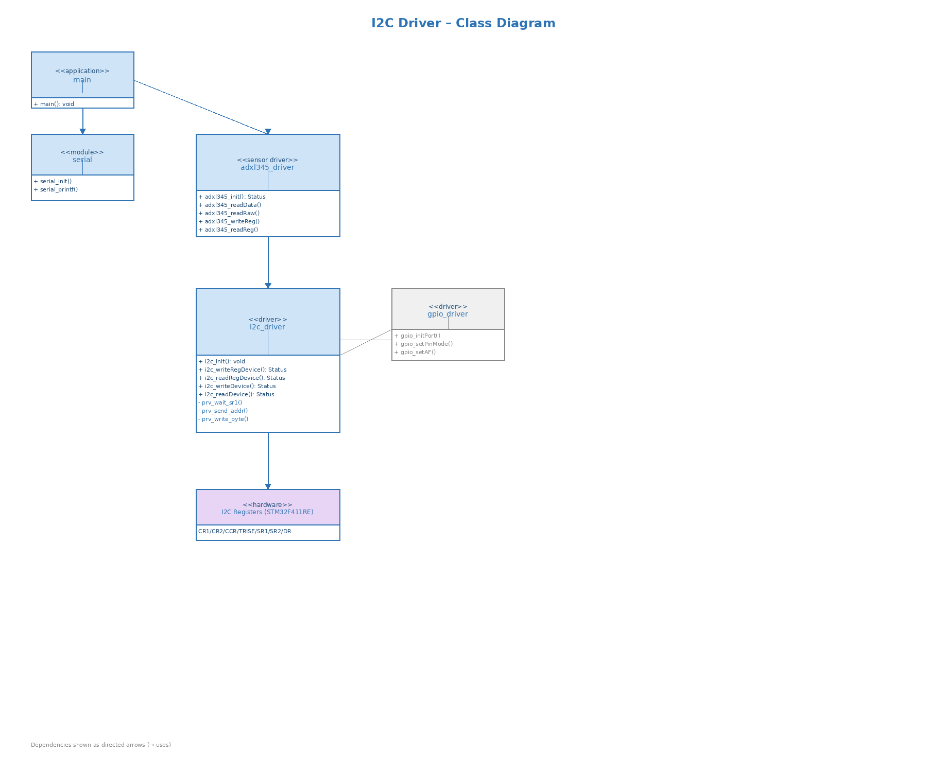
As shown in Fig. 1, main.c depends on adxl345_driver and serial. adxl345_driver depends exclusively on i2c_driver. i2c_driver is the only class that accesses the Hardware Layer. Private helpers (minus prefix) are internal to i2c_driver.c.

3.2. Module Behavior

Initial State
After i2c_init(): I2C1 in Standard Mode 100 kHz, PB8/PB9 as AF4 open-drain, CR2=16, CCR=80, TRISE=17, PE=1. No transactions in progress.

Event: Register Write Transaction
i2c_writeRegDevice: prv_check_bus() -> prv_start() -> prv_send_addr(addr,0) -> prv_write_byte(reg) -> loop prv_write_byte(data[i]) -> prv_wait_btf() -> prv_stop().

Event: Register Read Transaction (Repeated START)
i2c_readRegDevice: write phase (START -> ADDR(W) -> REG -> BTF), then Repeated START -> ADDR(R). Single-byte: ACK disabled before ADDR, STOP before DR read. Multi-byte: ACK on, middle bytes via RXNE, at second-to-last byte BTF + ACK cleared, at last byte STOP + RXNE + read, ACK re-enabled.

Fig. 2 — Sequence Diagram: I2C Driver Initialization
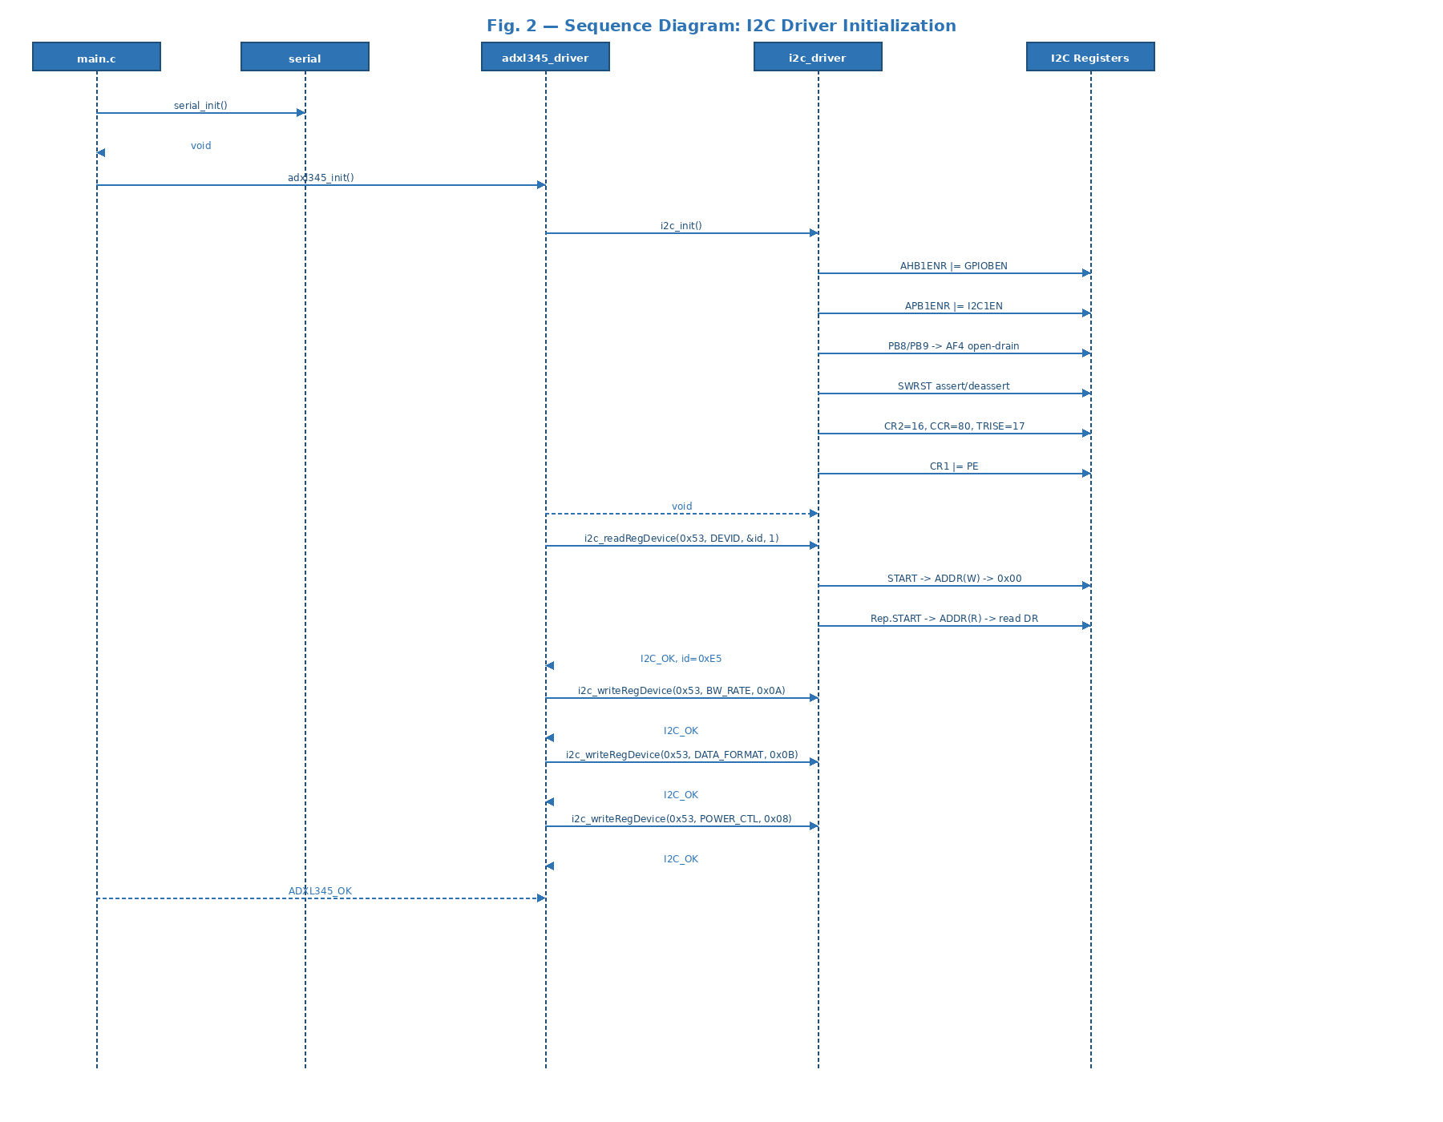
Fig. 2: main.c calls serial_init() then adxl345_init(). adxl345_init() calls i2c_init() (the only hardware configuration call), then reads DEVID, then writes BW_RATE, DATA_FORMAT, and POWER_CTL.

Fig. 3 — Activity Diagram: i2c_init() [FR-1, FR-2]
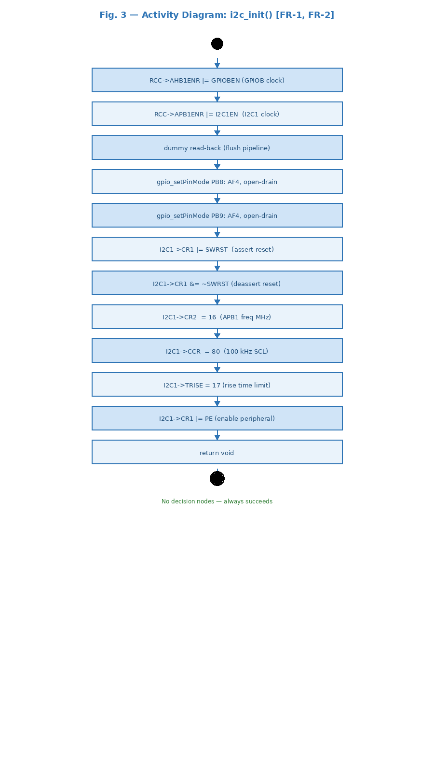
Fig. 3: Linear sequence — enable RCC clocks, configure PB8/PB9 as AF4, software reset, write timing registers, enable PE. No decision nodes — always succeeds.

Fig. 4 — Sequence Diagram: i2c_writeRegDevice() [FR-3, FR-4]
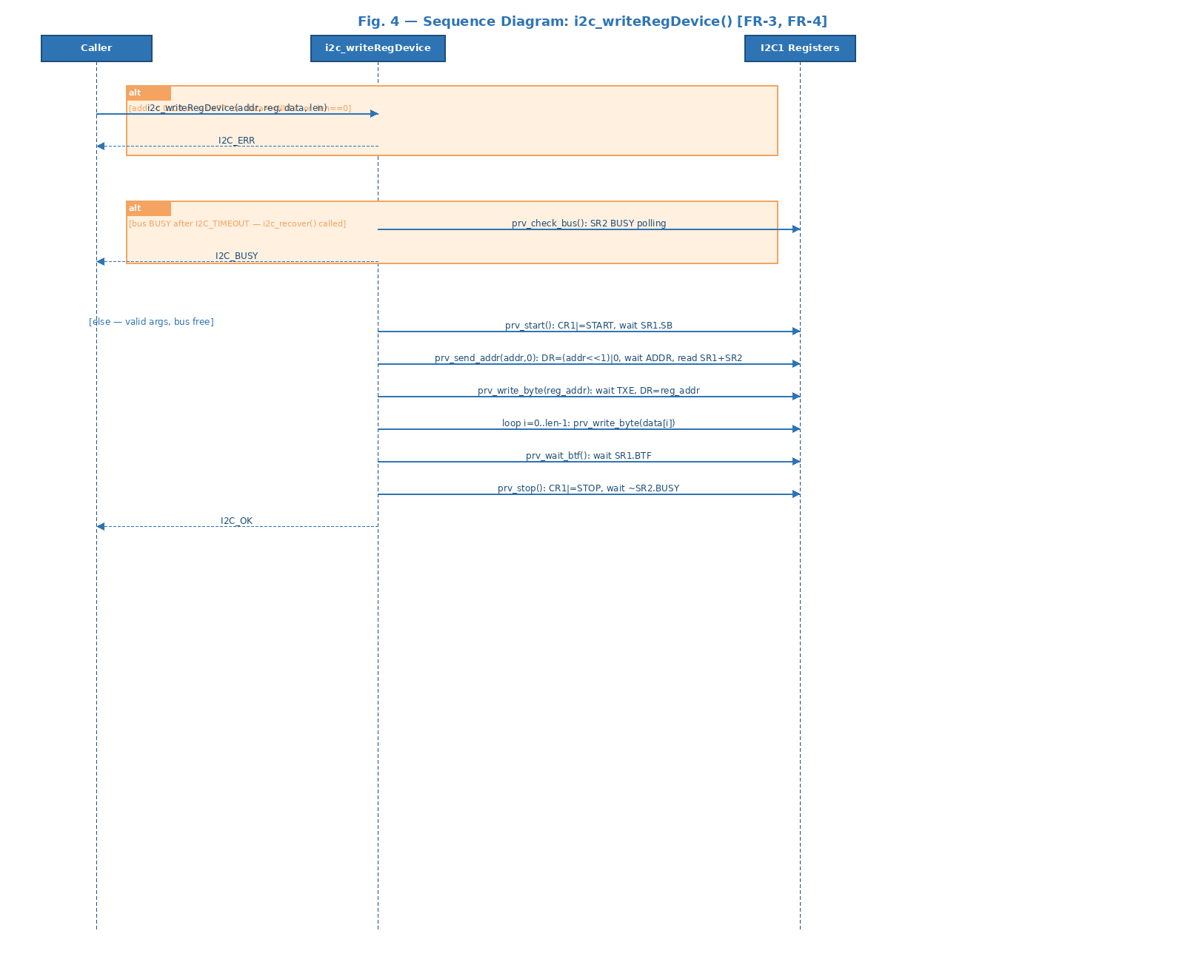
Fig. 4: Alt fragment for invalid args returns I2C_ERR. Alt for bus busy returns I2C_BUSY. Normal path: START -> ADDR(W) -> reg -> data loop -> BTF -> STOP.

Fig. 5 — Activity Diagram: i2c_writeRegDevice() [FR-3, FR-4]
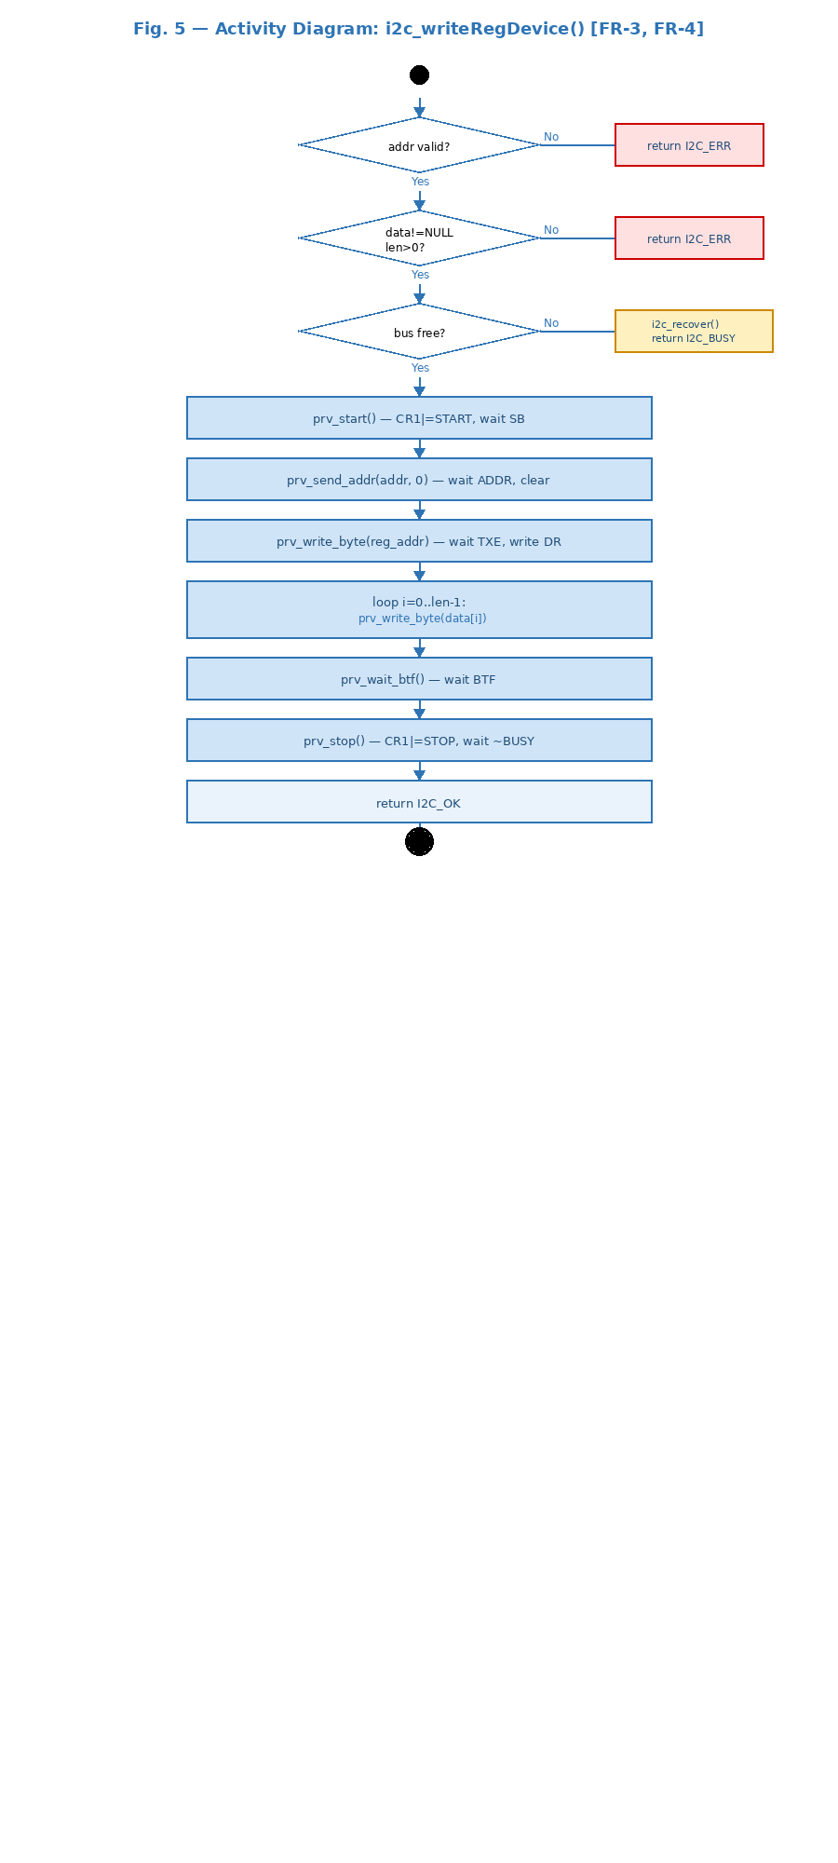
Fig. 5: Three decision nodes (address valid?, data/len valid?, bus free?) before the transaction sequence. All error paths exit before hardware access (NFR-2).

Fig. 6 — Sequence Diagram: i2c_readRegDevice() [FR-7, FR-8]
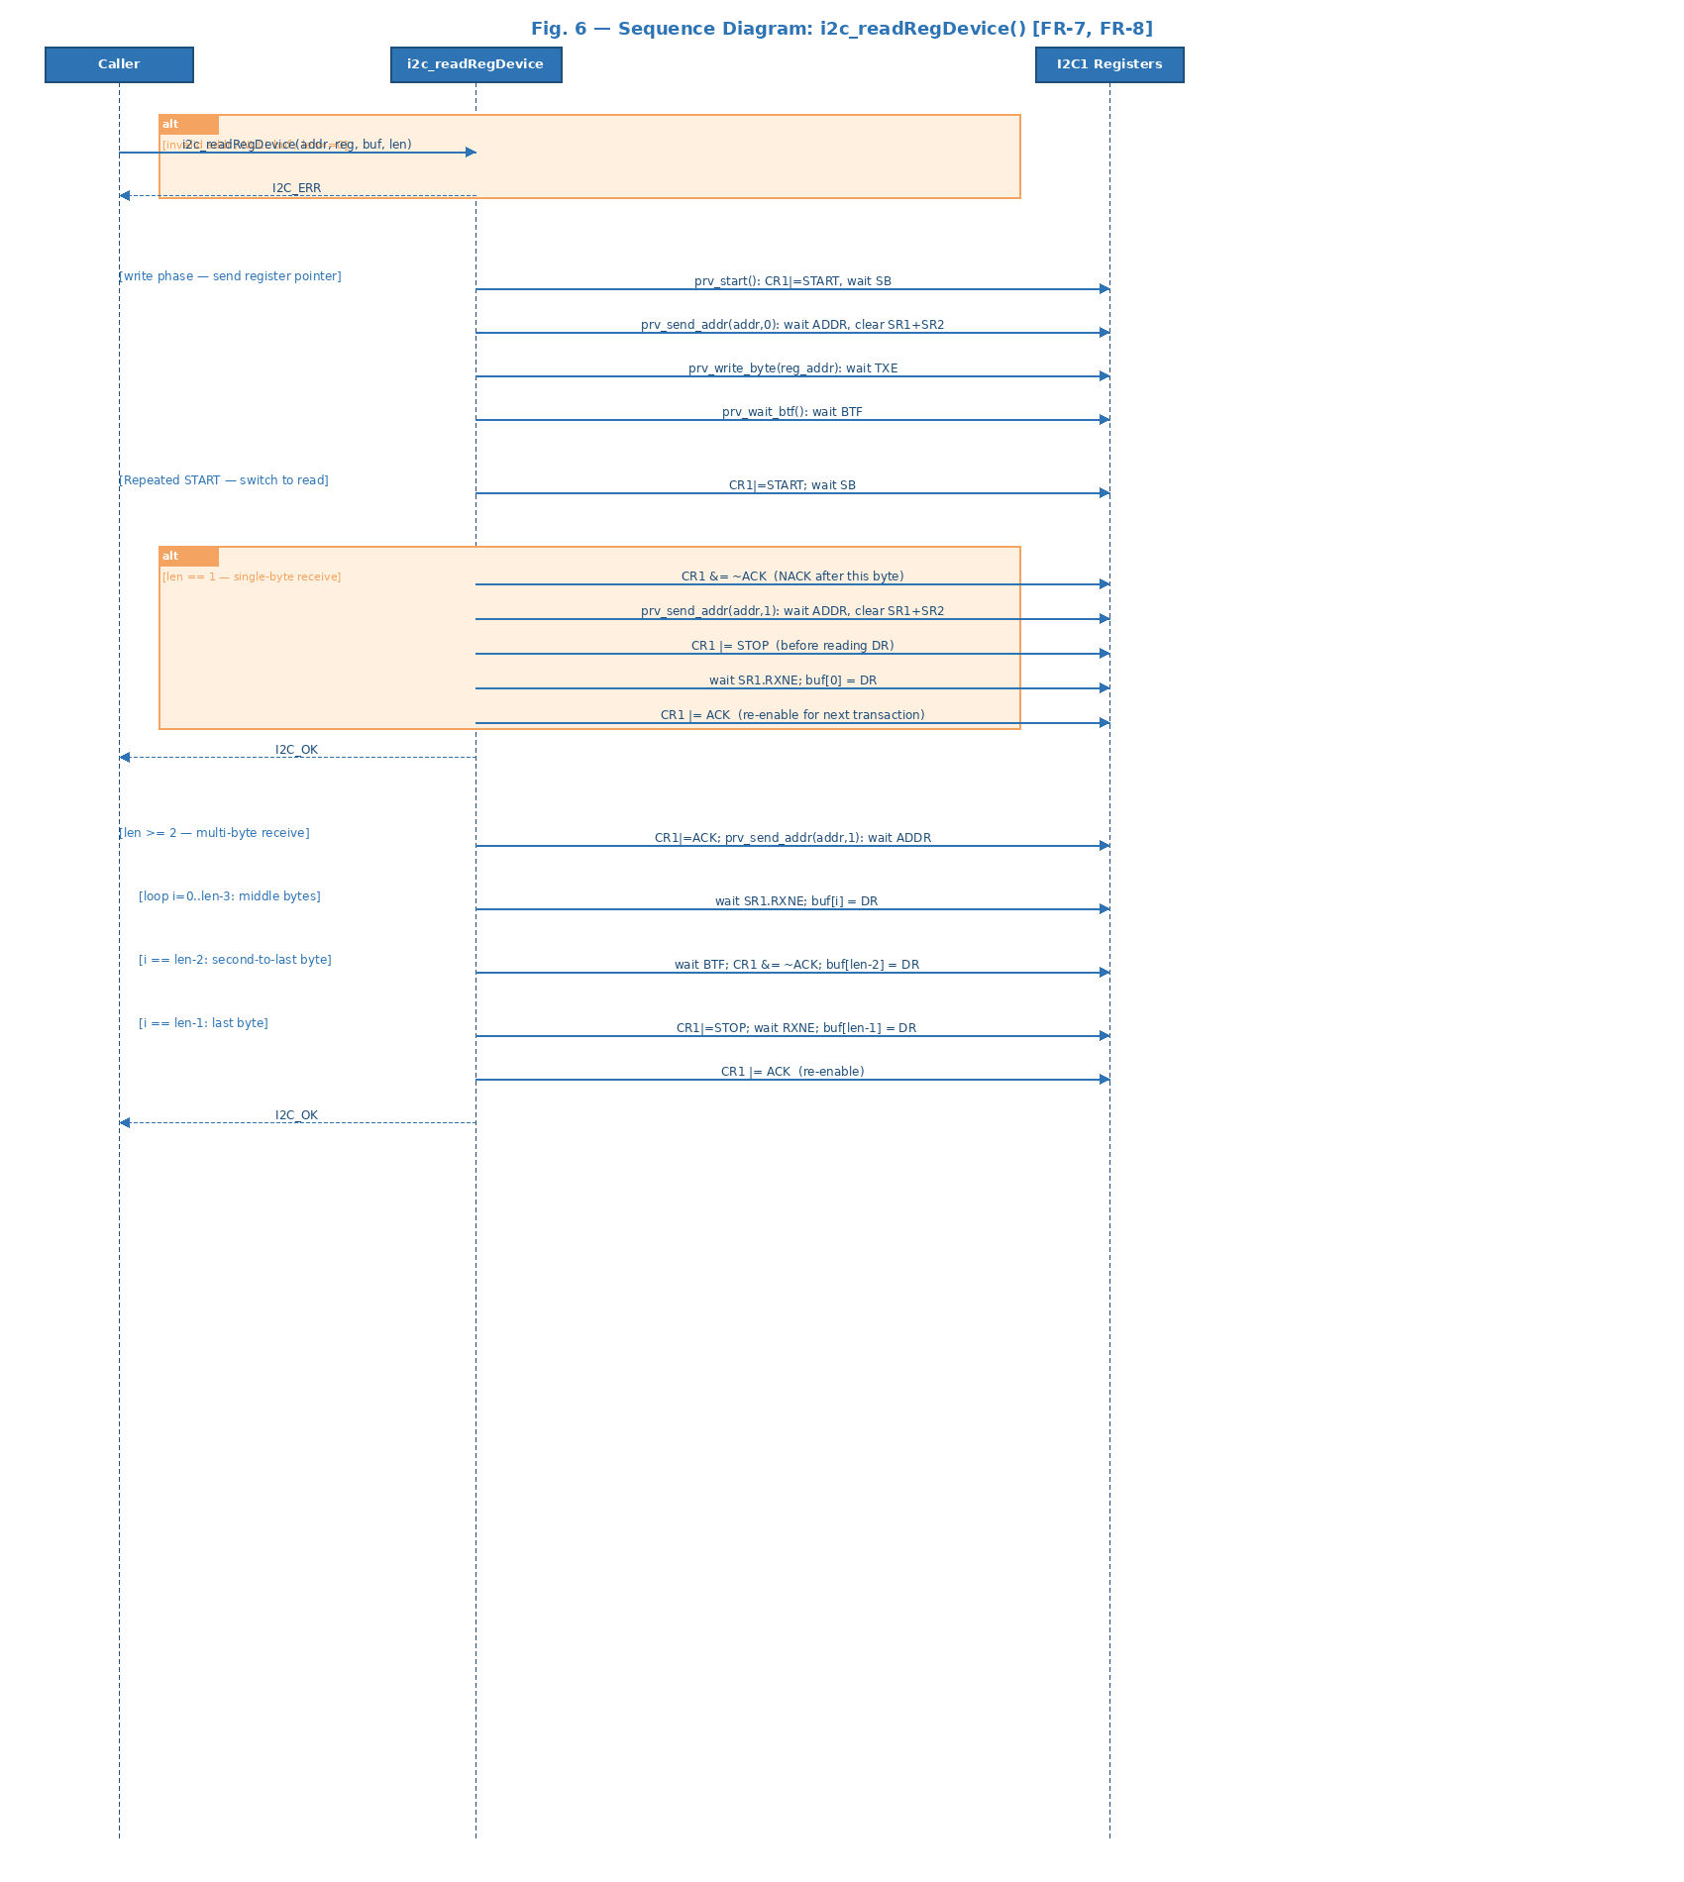
Fig. 6: Write phase sends register pointer. Alt fragment for len==1 shows ACK-disable/STOP-before-read sequence. Multi-byte path shows BTF+ACK-clear at second-to-last byte, STOP+RXNE at last byte.

Fig. 7 — State Diagram: I2C Driver
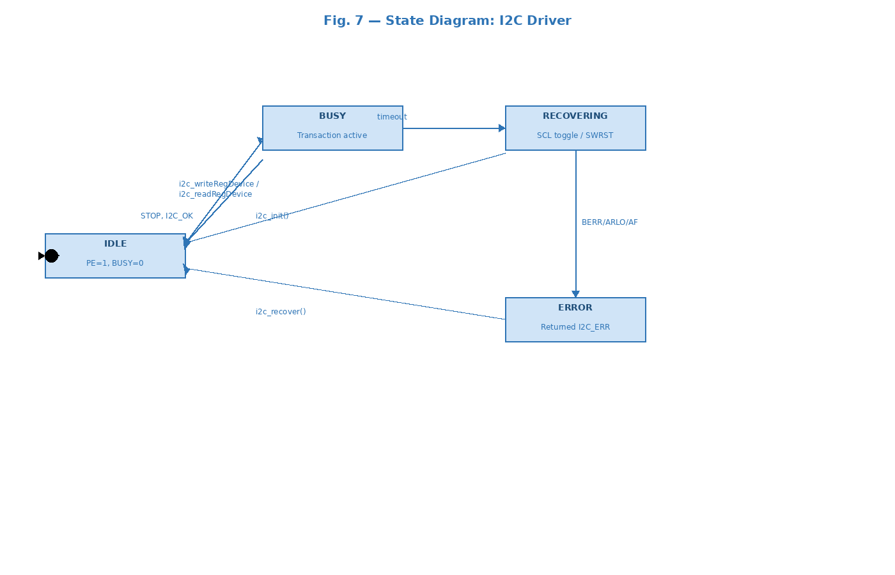
Fig. 7: IDLE -> BUSY on transaction start. BUSY -> IDLE on STOP/I2C_OK. BUSY -> RECOVERING on timeout. RECOVERING -> IDLE via i2c_init(). BUSY -> ERROR on BERR/ARLO/AF. ERROR -> IDLE via i2c_recover().

3.2.1. Per-Function Sequence and Activity Diagrams

i2c_init() — FR-1, FR-2: I2C Subsystem Initialization
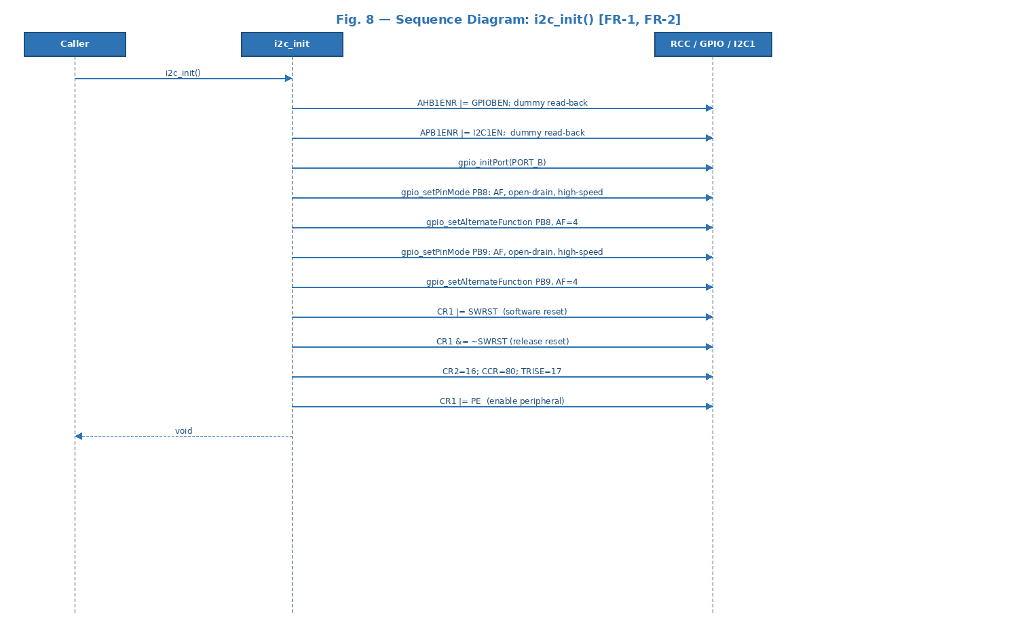
Fig. 8 — Sequence Diagram: i2c_init() sends 11 register writes/configurations to the hardware. Returns void — always succeeds.
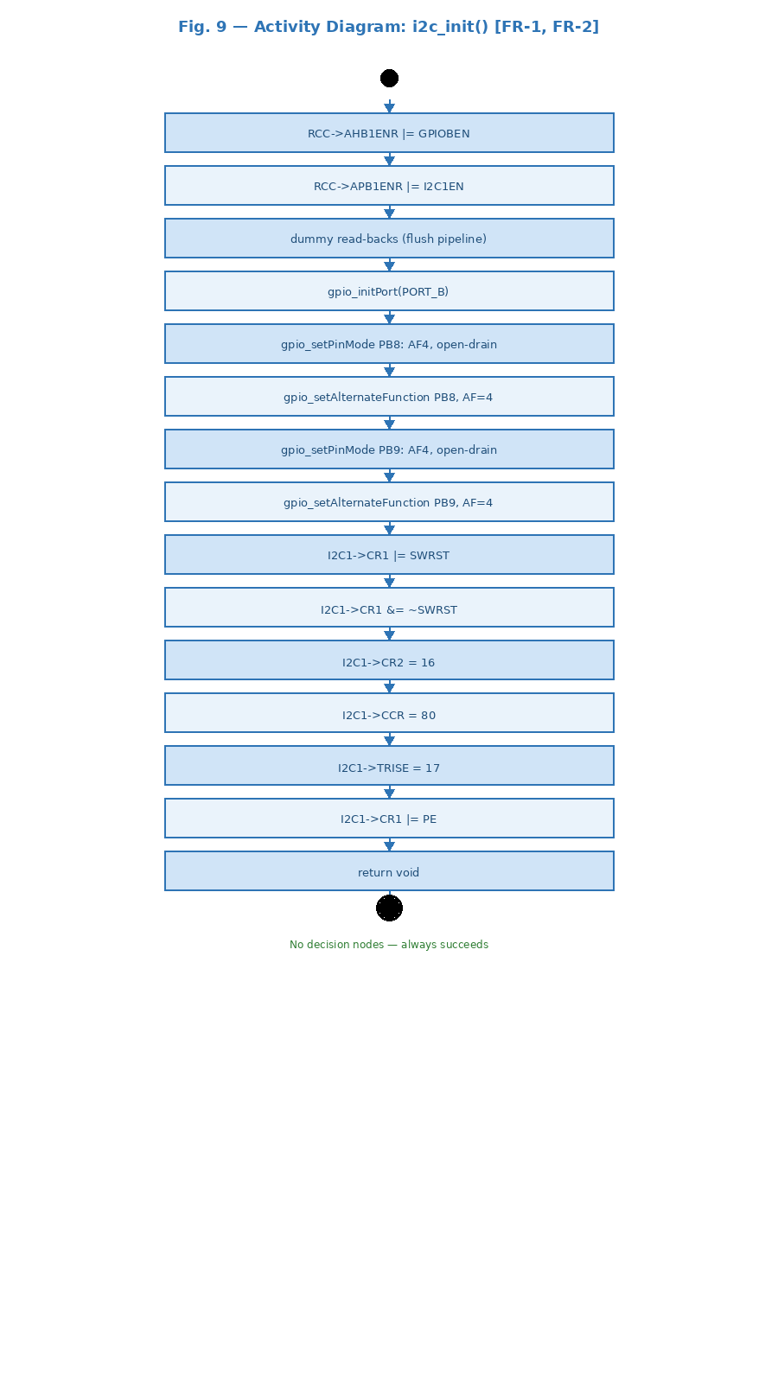
Fig. 9 — Activity Diagram: 15-step linear sequence. No decision nodes.

i2c_writeRegDevice() — FR-3, FR-4: Register Write
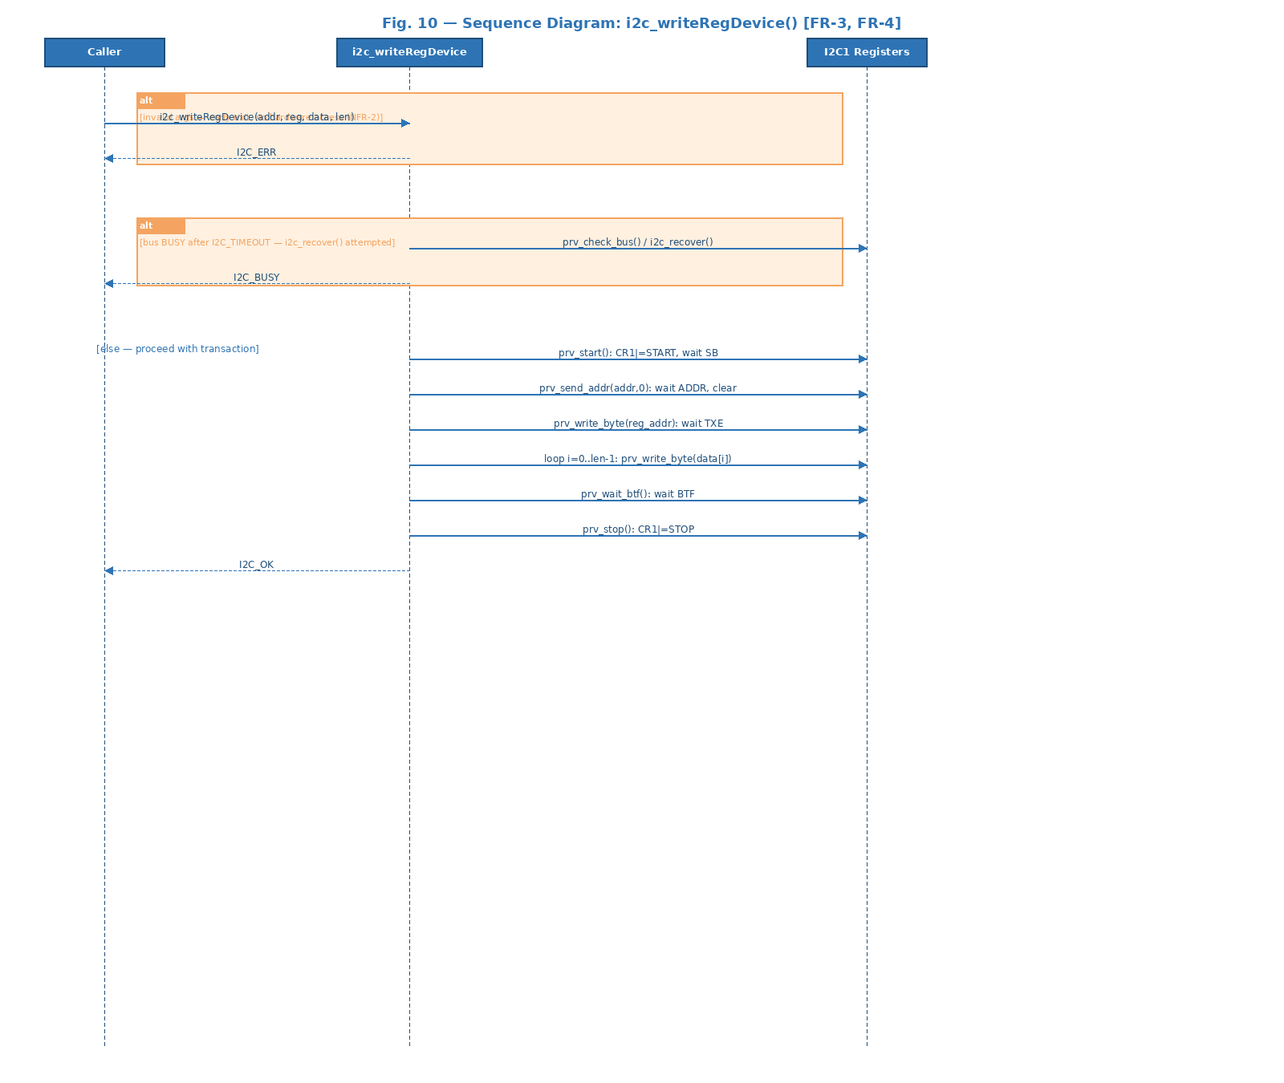
Fig. 10 — Sequence Diagram: Two alt fragments for early exit, then the full write transaction sequence.
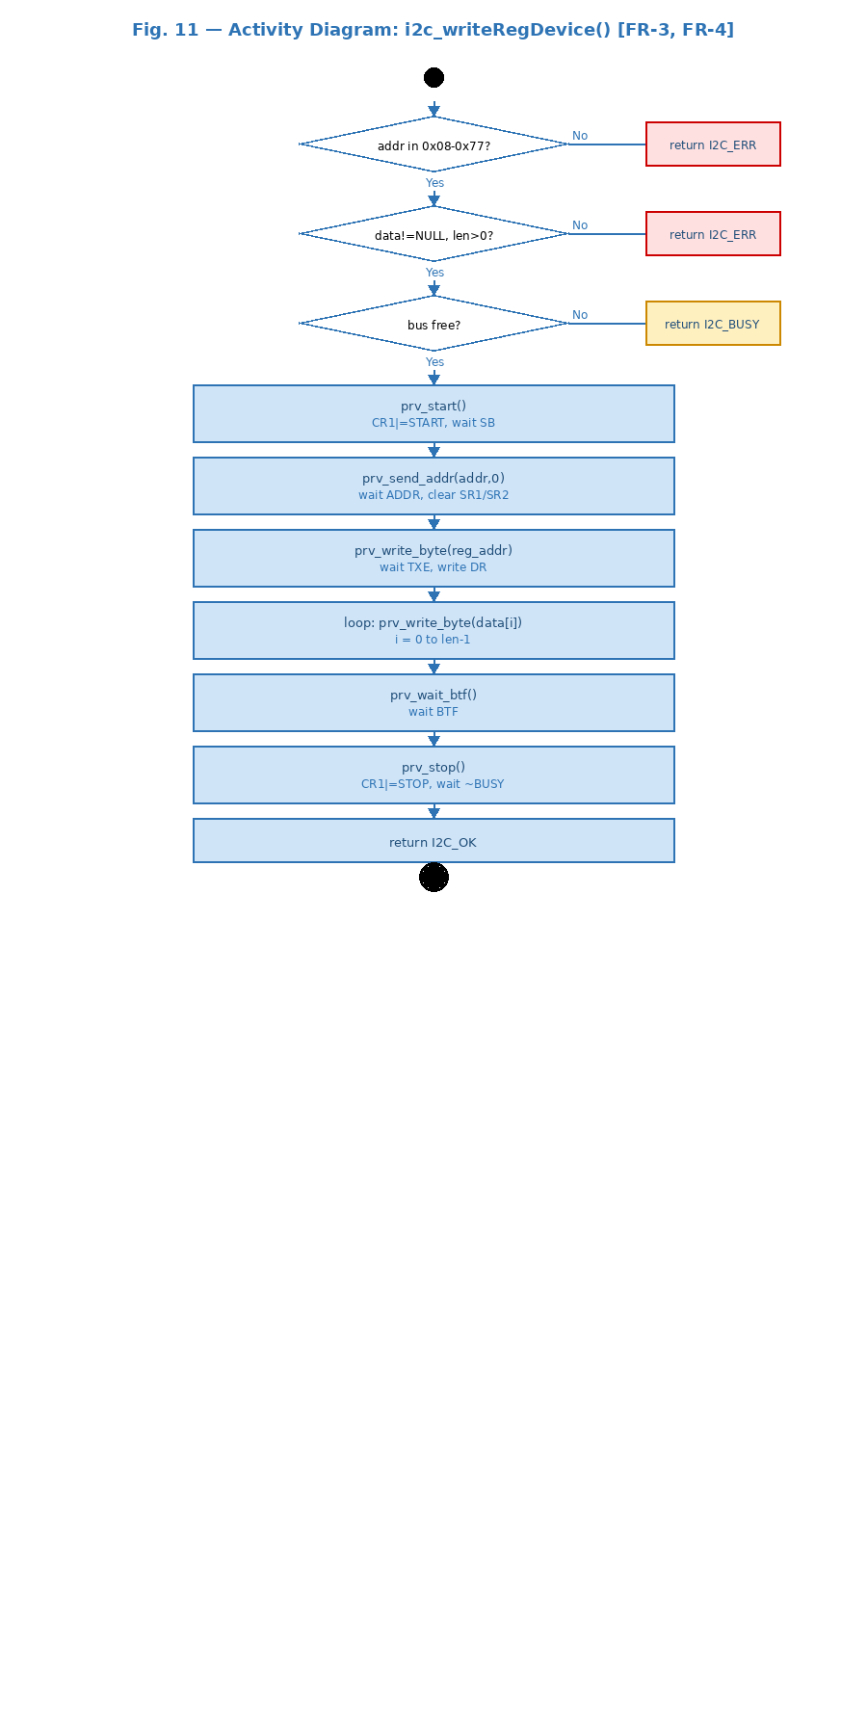
Fig. 11 — Activity Diagram: Three validation diamonds, then START -> ADDR(W) -> reg -> loop -> BTF -> STOP.

i2c_writeDevice() — FR-5, FR-6: Direct Write
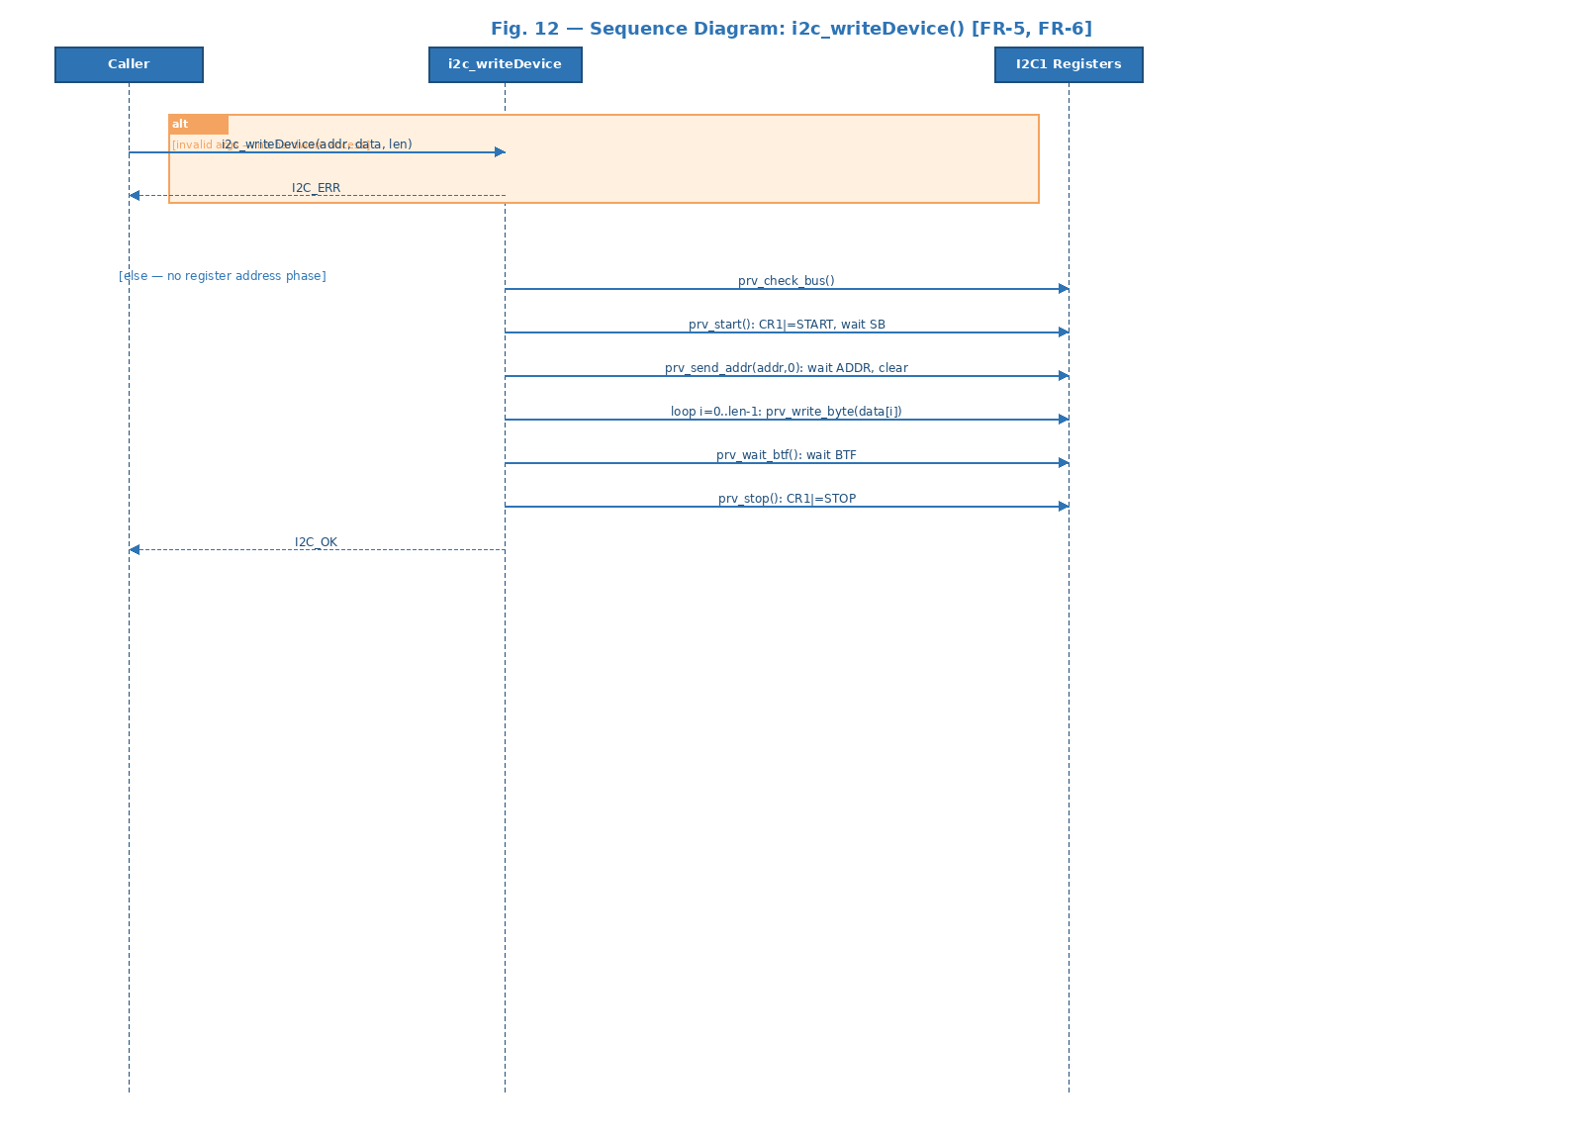
Fig. 12 — Sequence Diagram: Same as writeRegDevice but without register address phase.
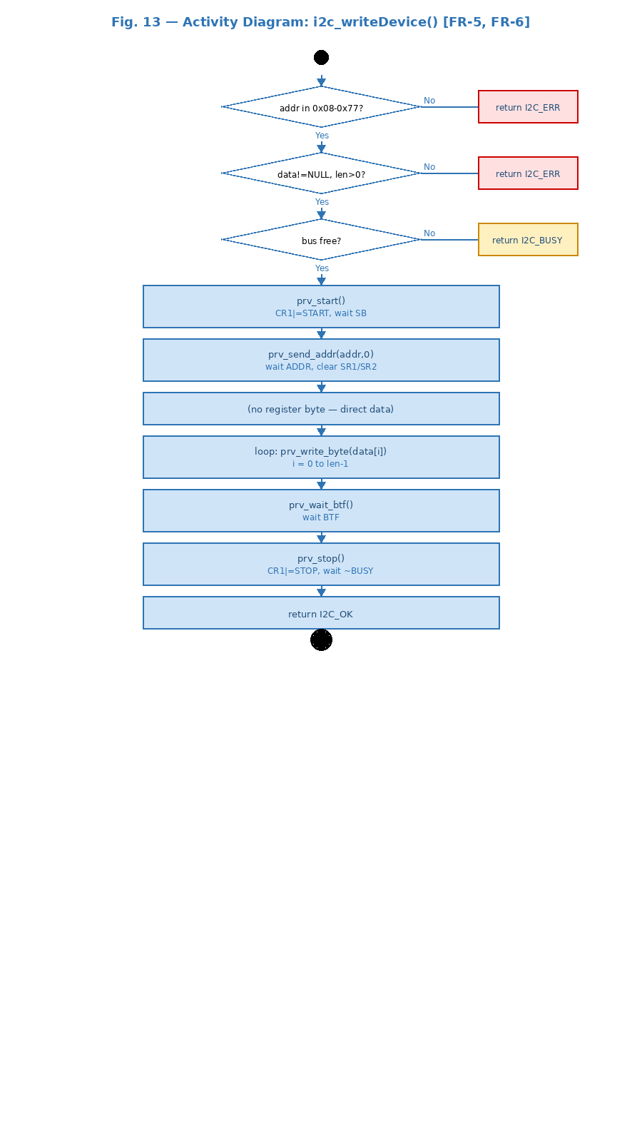
Fig. 13 — Activity Diagram: Same validation flow. Normal path skips reg_addr byte.

i2c_readRegDevice() — FR-7, FR-8: Register Read
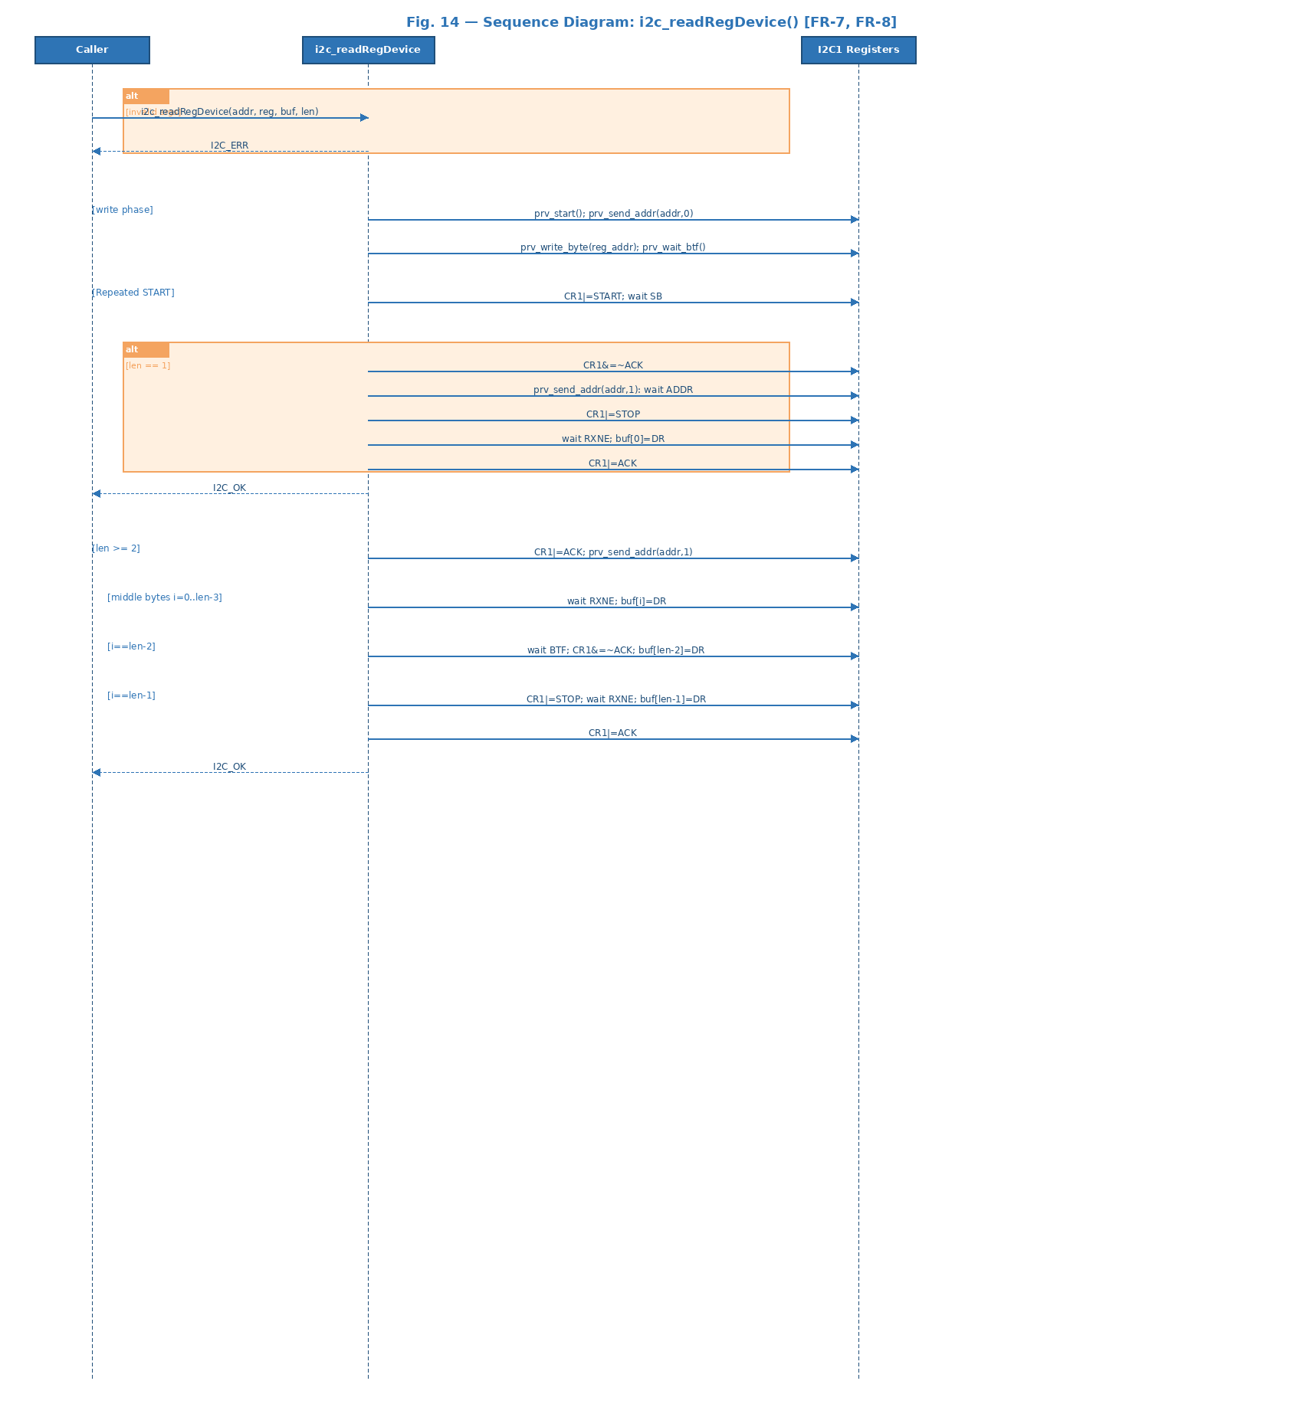
Fig. 14 — Sequence Diagram: Write phase + Repeated START + alt for len==1 + multi-byte loop with ACK management.
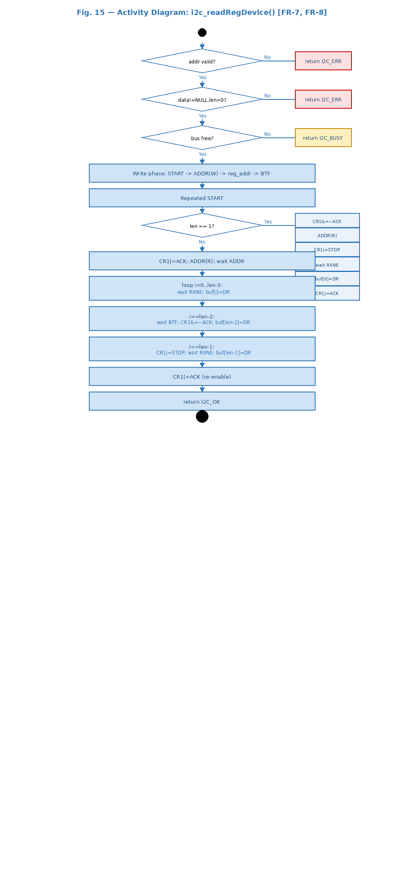
Fig. 15 — Activity Diagram: Validation diamonds, write phase, len==1 decision branch, multi-byte loop with second-to-last and last byte special handling.

i2c_readDevice() — FR-9, FR-10: Direct Read
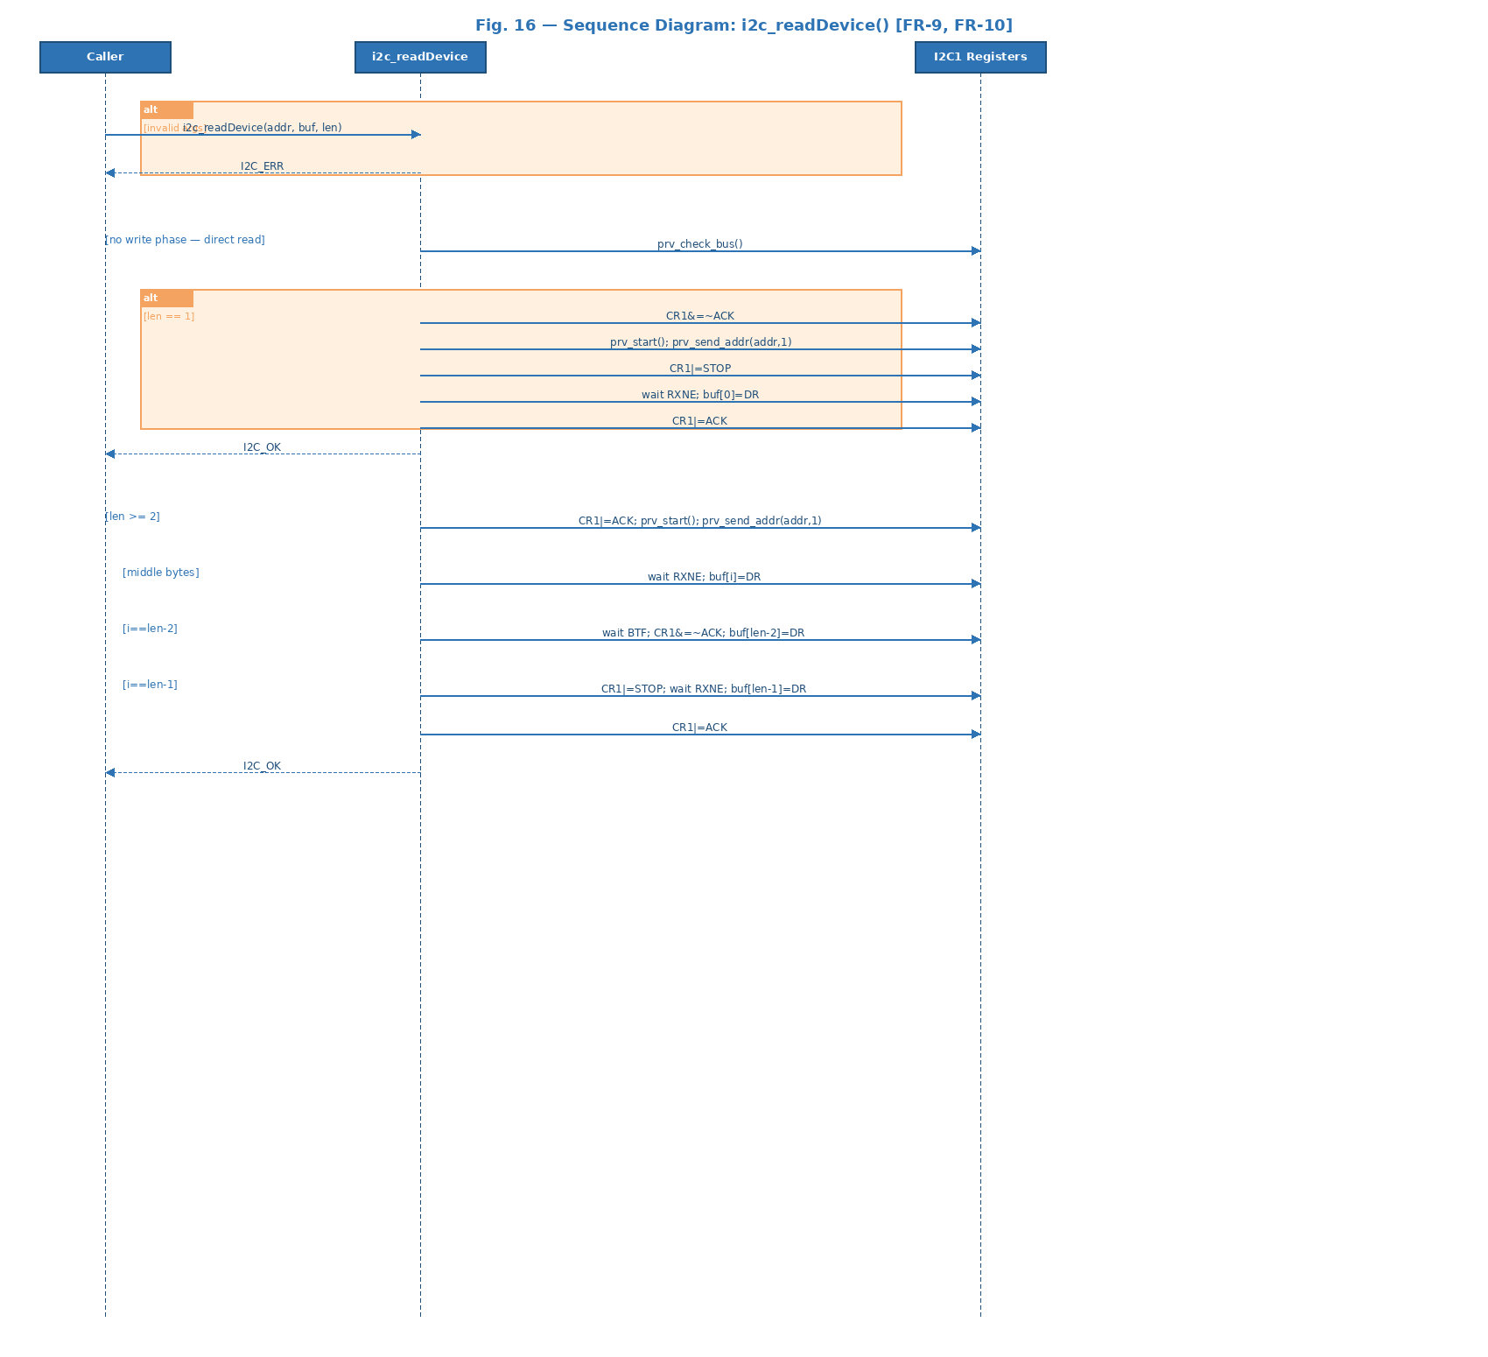
Fig. 16 — Sequence Diagram: No write phase. Direct START -> ADDR(R) -> receive sequence.
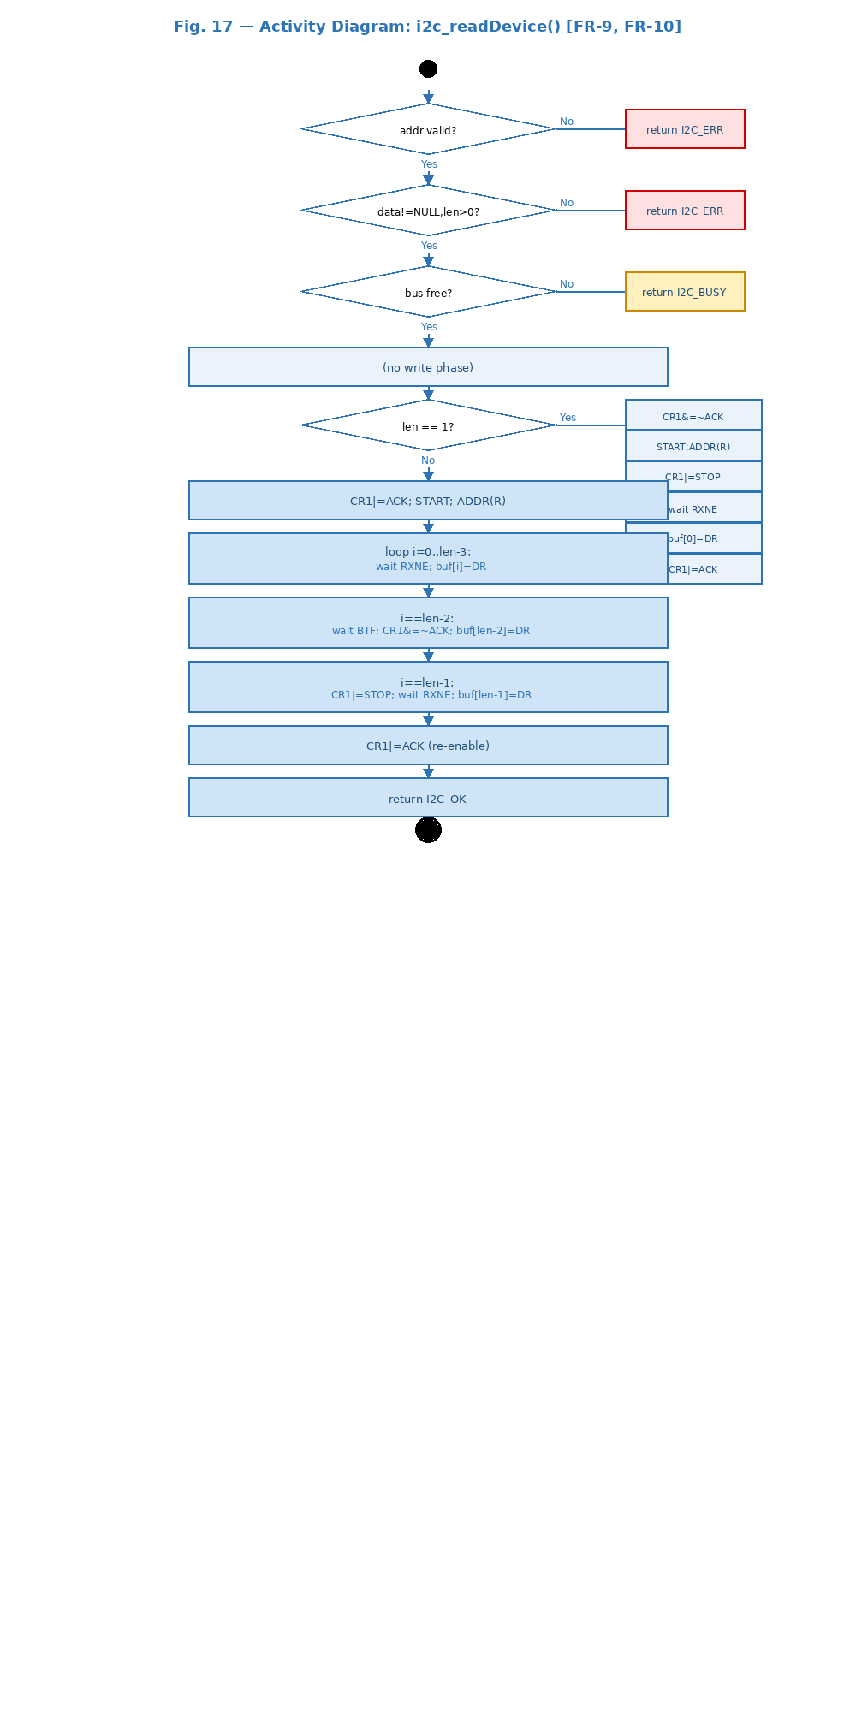
Fig. 17 — Activity Diagram: Same ACK/NACK management as readRegDevice but without write phase.

i2c_recover() — Bus Recovery
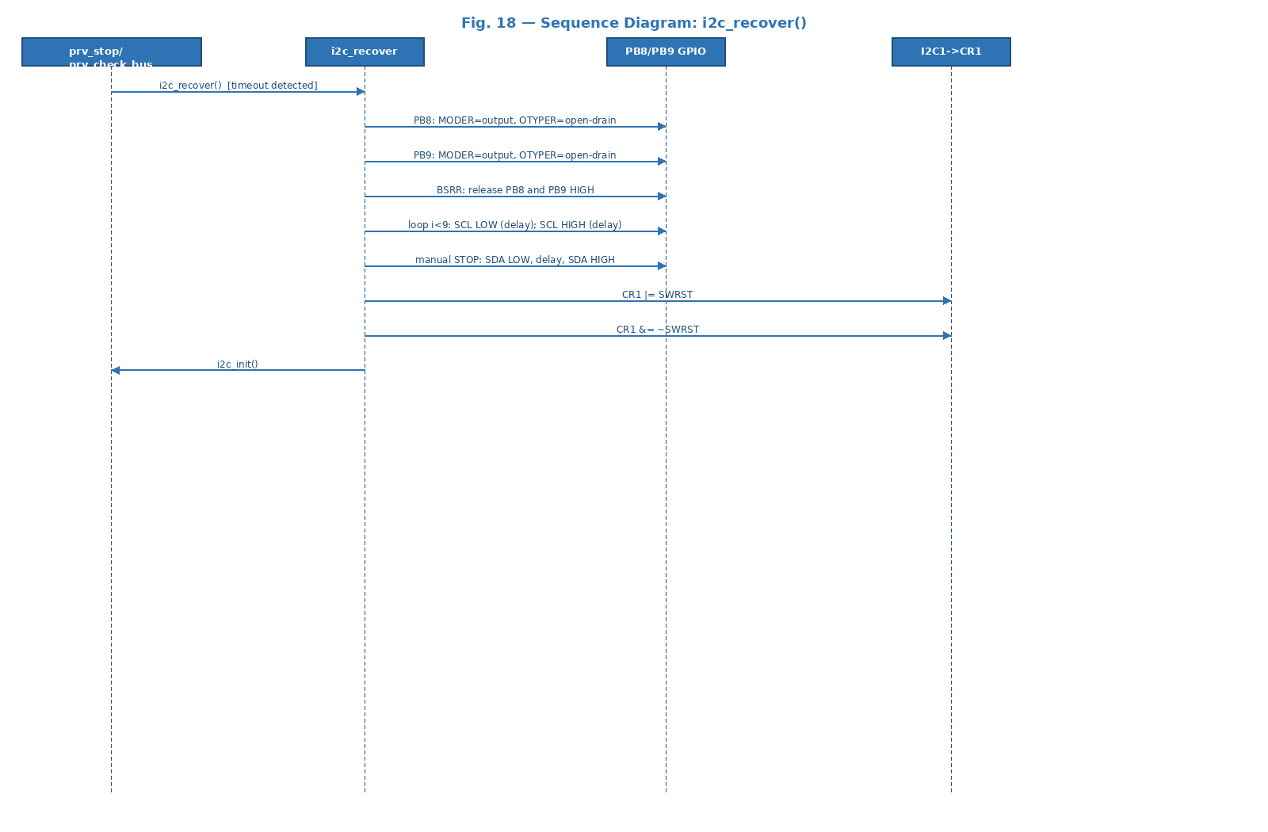
Fig. 18 — Sequence Diagram: Reconfigure GPIO -> toggle SCL up to 9 times -> manual STOP -> SWRST -> i2c_init().
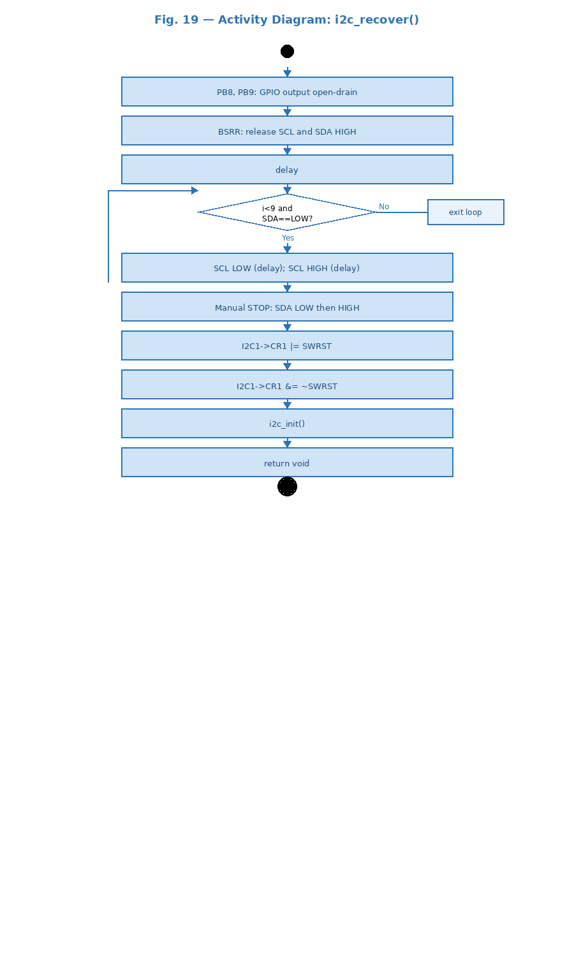
Fig. 19 — Activity Diagram: Loop node [i<9 and SDA==LOW] drives SCL toggling. Back-arrow shows loop. Exits to manual STOP and i2c_init().

3.3. I2C Driver — Internal Design

Internal Data Structures
The driver exposes no mutable global state. All hardware state is in peripheral registers. Ten private helpers are described below.
- prv_is_valid_addr(addr7) — Validates 7-bit address is in [0x08, 0x77].
- prv_wait_sr1(mask) — Polls SR1 with I2C_TIMEOUT; exits on flag set, timeout, or BERR|ARLO|AF.
- prv_has_error() — Checks and clears I2C_ERROR_FLAGS in SR1.
- prv_check_bus() — Verifies BUSY=0; calls i2c_recover() on timeout.
- prv_start() — Sets CR1 START, waits for SB.
- prv_send_addr(addr7,read) — Writes address to DR, waits ADDR, clears by reading SR1+SR2.
- prv_write_byte(byte) — Waits TXE, writes byte to DR.
- prv_wait_btf() — Waits BTF to confirm last byte fully shifted out.
- prv_stop() — Sets STOP, waits BUSY=0; calls i2c_recover() on timeout.
- prv_delay_cycles(n) — NOP loop for timing in i2c_recover().

Multi-byte Read Protocol (RM0383 Fig. 164)
At i==(len-2): BTF waited (DR and shift register both full), ACK cleared, byte read from DR. At i==(len-1): STOP set, RXNE polled, last byte read, ACK re-enabled. For len==2: i==0 is immediately the second-to-last byte, i==1 the last — handled naturally by the loop.

Error Handling
Validate-before-access: address, NULL, len checks precede any register write. Hardware errors cleared atomically. Timeout in any loop returns I2C_ERR or triggers i2c_recover(). Error codes: I2C_OK=0, I2C_ERR=1, I2C_BUSY=2.

4. Application Programming Interfaces

4.1. Data Types and Macros
- I2C_Status_t: I2C_OK=0, I2C_ERR=1, I2C_BUSY=2.
- I2C_ADDR_MIN / I2C_ADDR_MAX: 0x08 / 0x77 — valid 7-bit range.
- I2C_TIMEOUT: 160000 cycles (~10 ms at 16 MHz).
- I2C_CR2_FREQ_MHZ: 16 — APB1 frequency in MHz.
- I2C_CCR_SM_100K: 80 — CCR = fAPB1/(2×100kHz) = 80.
- I2C_TRISE_SM: 17 — TRISE = 16 + 1 for Standard Mode.

Register | Offset | Access | Used by Function(s) | Purpose in Driver
RCC->AHB1ENR | 0x40023830 | R/W | i2c_init() | Enable GPIOB clock (bit 1).
RCC->APB1ENR | 0x40023840 | R/W | i2c_init() | Enable I2C1 clock (bit 21).
I2C1->CR1 | 0x40005400 | R/W | All functions | PE, START, STOP, ACK, SWRST bits.
I2C1->CR2 | 0x40005404 | R/W | i2c_init() | FREQ=16 (APB1 MHz for timing).
I2C1->CCR | 0x4000541C | R/W | i2c_init() | CCR=80 for 100 kHz SCL.
I2C1->TRISE | 0x40005420 | R/W | i2c_init() | TRISE=17 for rise time limit.
I2C1->SR1 | 0x40005414 | R/W | prv_wait_sr1, prv_has_error | SB,ADDR,TXE,RXNE,BTF polled; BERR,ARLO,AF checked.
I2C1->SR2 | 0x40005418 | R | prv_send_addr, prv_check_bus | BUSY checked; read after SR1 clears ADDR.
I2C1->DR | 0x40005410 | R/W | prv_write_byte, read functions | Write: byte shifted out; Read: byte received.

4.2. Error Codes
Code | Value | Returned By | Trigger Condition
I2C_OK | 0 | All (except init/recover) | Successful operation.
I2C_ERR | 1 | All transaction functions | Invalid addr, NULL buf, len==0, flag timeout, BERR/ARLO/AF.
I2C_BUSY | 2 | All transaction functions | Bus BUSY after I2C_TIMEOUT even after i2c_recover().

4.3. Function Definitions

i2c_init
Function Name | i2c_init
Syntax | void i2c_init(void)
Parameters (in) | N/A
Parameters (inout) | N/A
Parameters (out) | N/A
Return value | void — Always succeeds.
Description | Initializes I2C1 in Standard Mode 100 kHz (FR-1, FR-2). Enables RCC clocks, configures PB8/PB9 as AF4 open-drain, performs SWRST, writes CR2=16/CCR=80/TRISE=17, enables PE.
Constraints | Must be called before any transaction function. Does not start any transaction.
Available via | i2c_driver.h

i2c_recover
Function Name | i2c_recover
Syntax | void i2c_recover(void)
Parameters (in) | N/A
Parameters (inout) | N/A
Parameters (out) | N/A
Return value | void — Attempts recovery.
Description | Recovers a hung bus: reconfigures PB8/PB9 as GPIO output, toggles SCL up to 9 times, generates manual STOP, asserts/deasserts SWRST, calls i2c_init(). Called automatically on timeout.
Constraints | gpio_initPort() must be idempotent if other GPIOB pins are in use.
Available via | i2c_driver.h

i2c_writeRegDevice
Function Name | i2c_writeRegDevice
Syntax | I2C_Status_t i2c_writeRegDevice(uint8_t dev_addr, uint8_t reg_addr, const uint8_t *data, uint32_t len)
Parameters (in) | dev_addr (0x08-0x77), reg_addr, data (non-NULL), len (>0).
Parameters (inout) | N/A
Parameters (out) | N/A
Return value | I2C_OK / I2C_ERR / I2C_BUSY
Description | Writes to device register (FR-3, FR-4): START -> ADDR(W) -> reg -> DATA[0..n] -> BTF -> STOP. Validates args before hardware access.
Constraints | ACK failure returns I2C_ERR. Bus errors detected and reported.
Available via | i2c_driver.h

i2c_writeDevice
Function Name | i2c_writeDevice
Syntax | I2C_Status_t i2c_writeDevice(uint8_t dev_addr, const uint8_t *data, uint32_t len)
Parameters (in) | dev_addr (0x08-0x77), data (non-NULL), len (>0).
Parameters (inout) | N/A
Parameters (out) | N/A
Return value | I2C_OK / I2C_ERR / I2C_BUSY
Description | Direct write without register phase (FR-5, FR-6): START -> ADDR(W) -> DATA[0..n] -> BTF -> STOP.
Constraints | First data byte is first byte slave receives after address ACK.
Available via | i2c_driver.h

i2c_readRegDevice
Function Name | i2c_readRegDevice
Syntax | I2C_Status_t i2c_readRegDevice(uint8_t dev_addr, uint8_t reg_addr, uint8_t *data, uint32_t len)
Parameters (in) | dev_addr (0x08-0x77), reg_addr, data (non-NULL), len (>0).
Parameters (inout) | N/A
Parameters (out) | data — filled with len bytes from device starting at reg_addr.
Return value | I2C_OK / I2C_ERR / I2C_BUSY
Description | Register read with Repeated START (FR-7, FR-8). Handles single-byte and multi-byte per RM0383 Fig. 164. ACK re-enabled after transaction.
Constraints | len==2 handled correctly: i==0 triggers BTF+ACK-clear, i==1 triggers STOP+RXNE.
Available via | i2c_driver.h

i2c_readDevice
Function Name | i2c_readDevice
Syntax | I2C_Status_t i2c_readDevice(uint8_t dev_addr, uint8_t *data, uint32_t len)
Parameters (in) | dev_addr (0x08-0x77), data (non-NULL), len (>0).
Parameters (inout) | N/A
Parameters (out) | data — filled with len bytes.
Return value | I2C_OK / I2C_ERR / I2C_BUSY
Description | Direct read without register phase (FR-9, FR-10): START -> ADDR(R) -> DATA[0..n] -> STOP. Same ACK/NACK management as readRegDevice.
Constraints | No write phase. Reading starts immediately after address ACK. ACK re-enabled after transaction.
Available via | i2c_driver.h

4.4. Internal Function Definitions

prv_is_valid_addr
Function Name | prv_is_valid_addr
Syntax | static uint8_t prv_is_valid_addr(uint8_t addr7)
Parameters (in) | addr7 — 7-bit address to validate (0x08-0x77).
Return value | 1 if valid, 0 if reserved/out-of-range.
Description | Validates address against I2C specification reserved ranges. Called by all public functions before hardware access (NFR-2).
Constraints | Static in i2c_driver.c. Not in public API.

prv_wait_sr1
Function Name | prv_wait_sr1
Syntax | static uint8_t prv_wait_sr1(uint32_t mask)
Parameters (in) | mask — SR1 flag(s) to wait for (SB, ADDR, TXE, RXNE, BTF).
Return value | 1 if flags set; 0 on timeout or BERR|ARLO|AF.
Description | Central flag-polling helper. Satisfies NFR-3 by bounding all waits with I2C_TIMEOUT.
Constraints | Static in i2c_driver.c. Must not be called with PE=0.

prv_check_bus
Function Name | prv_check_bus
Syntax | static I2C_Status_t prv_check_bus(void)
Parameters (in) | N/A
Return value | I2C_OK if bus free; I2C_BUSY if BUSY persists after timeout and recovery.
Description | Checks SR2 BUSY before transaction. Calls i2c_recover() on timeout.
Constraints | Static in i2c_driver.c. First hardware check in all public transaction functions.

5. Future Enhancements
- Interrupt-driven transactions: i2c_writeRegDevice_IT() / i2c_readRegDevice_IT() using I2C EV/ER IRQs to eliminate CPU polling.
- DMA support: zero-copy burst transfers for high-throughput sensor data.
- 10-bit addressing: extend prv_send_addr() and prv_is_valid_addr() for 10-bit devices.
- Multi-master arbitration: explicit ARLO retry logic for multi-master bus configurations.
- Configurable clock speed: parameterize i2c_init() to support Fast Mode (400 kHz) and Fast Mode Plus (1 MHz).

